Week 4 - Money Lab

Luca Novello | 038515003 | gnovello | October 4, 2024

## Transaction Class:

The transaction class can be used for both income and expense transactions as it maintains the same attributes. The transactionType will be used to help identify between the different transaction types.

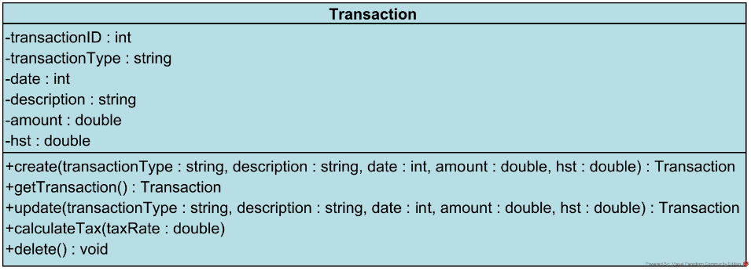

## Create New Transaction (Income and Expense Transactions):

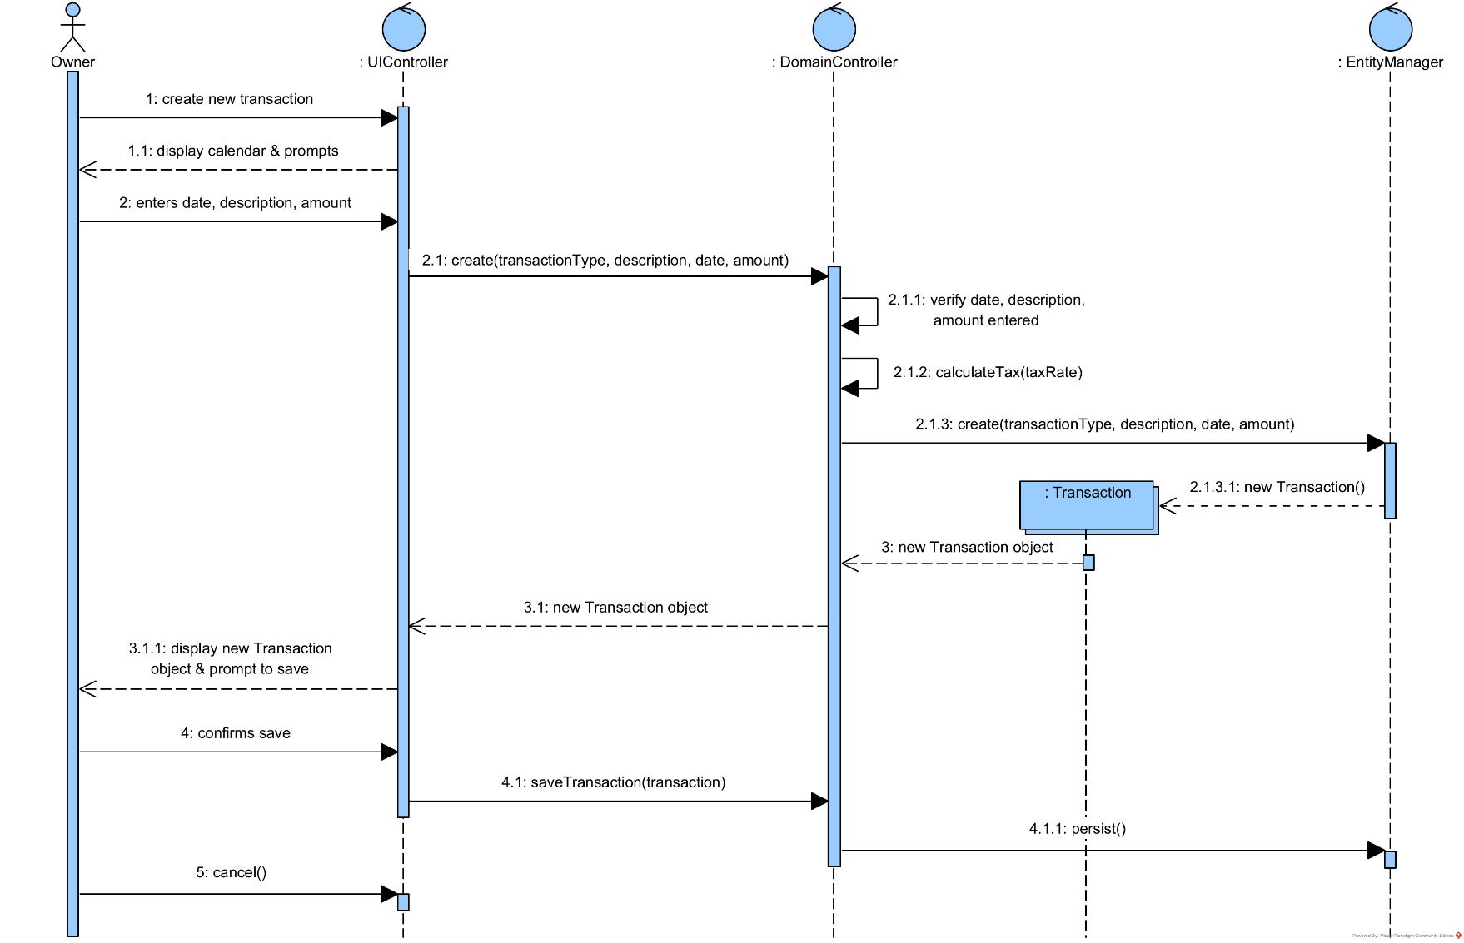

## Query Financial Transactions (Income and Expense Transactions):

When performing a query, the Domain Controller can loop through and get all the matching transactions, parse through and calculate the query parameters, and display the results.

